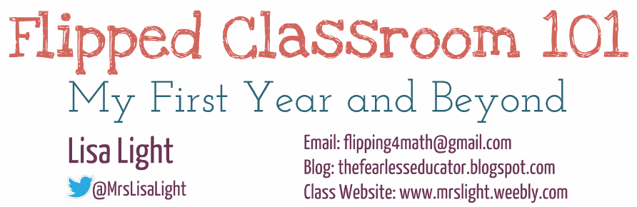
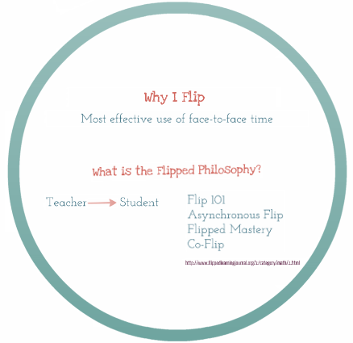  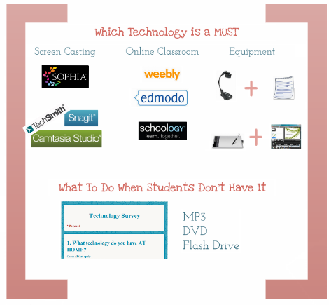 | 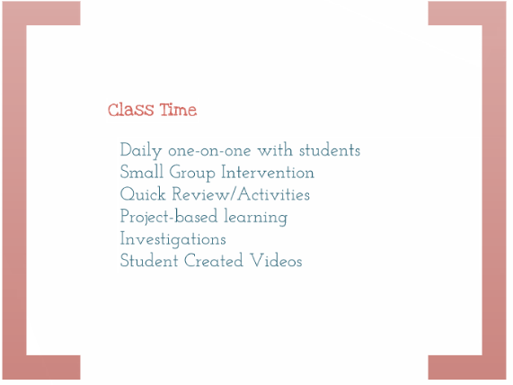  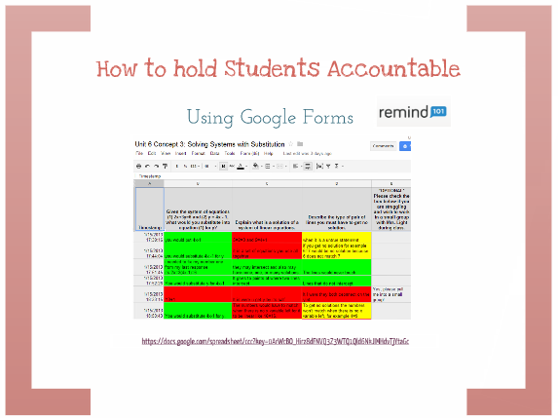  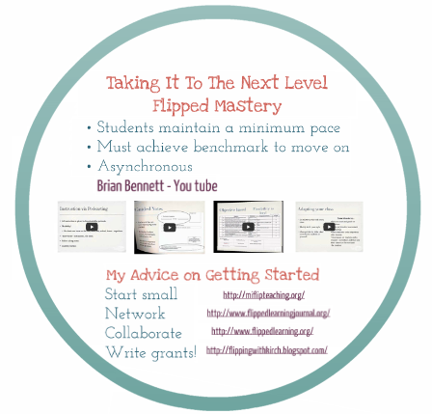

Video Recording
Jing |  | Snag It |  | Camtasia
www.techsmith.com
- 5 minute limit  - No editing  - FREE |  | - 10+ minutes  - No editing  - $29.95 (ed price) |  | - Unlimited length  - Full editing  - $179 (ed price)
Video Sharing |  |  |  | Video Recording & Sharing
Screencast  www.screencast.com |  | Edmodo/Schoology |  | Sophia  www.sophia.org
- 2 GB storage  - FREE  - Pro 25 GB $9.95/month |  | - Unlimited  - FREE  - Must sign in to use |  | - Unlimited  - FREE  - Easy, quiz, playlists  - Flipped Certification  - Webinars
Online Classroom
Weebly  www.weebly.com |  | Edmodo  www.edmodo.com |  | Schoology  www.schoology.com
- FREE  - Website hosting  - Post videos  (Pro version directly or use other free service)  - Embed documents, Google forms, etc. |  | - FREE  - Discussion boards  - Post videos  - Submit assignments  - Quizzes  - Need to register/sign in |  | - FREE  - Discussion boards  - Post videos  - Submit assignments  - Quizzes  - Need to register/sign in
Communication
- Remind 101
- available on its own or through Schoology
Equipment (not all are necessary)
Document Camera | Interactive Whiteboard |  | Tablet www.wacom.com |  | Video Camera
- Write on paper and record screen | - Write on board and record screen |  | - Write over PowerPoint and record screen |  | - Write on whiteboard/paper and record
Other Essentials
Twitter  www.twitter.com |  | Google  www.google.com |  | Other Websites
- #flipclass  Mondays at 8pm  - @MrsLisaLight |  | - GDrive  - Google Forms  - Google Documents  - Google Voice |  | - flippedlearningjournal.org  - flippedlearning.org  - flippingwithkirch.blogspot.com
APP available for your phone

